[cover sheet]

3

ASSIGNMENT 3

**CYCLOMATIC COMPLEXITY, PHASE 2**

CSE 6329 -- SOFTWARE MEASUREMENT AND QUALITY ENGINEERING

Professor Dennis J. Frailey

**Fall, 2019**

|  |  |
| --- | --- |
| NAME | STUDENT ID NUMBER |
| **Balaji Gurumoorthy** | **1001680348** |
| **Goutami Padmanabhan** | **1001669338** |

|  |  |
| --- | --- |
| **Name of Program Evaluated** | **Discussion of Any Errors Found and How to Correct Them** |
| Red2.c | 1. For Case 1: Mean=Median i.e. even size input, eg: 3,6,2,1,4,5 we get the maximum element of input array i.e.6 as mode instead of minimum element 1.   Solution: The above error can be handled by initializing a variable to minimum element of array i.e. modevariable = outArray[0];  After comparing count and maxcount, instead of this statement can be used “modevariable= outArray[i];” and outside of for loop  *mode= modevariable can be performed inorder to get the minimum value of the input element if there is no repeating elements in input array.   1. For Case 2: Mean=Median i.e. odd size input, eg: 3,6,2,1,4,5,6 we get the maximum element of input array i.e.6 as mode which is correct but the logic implemented as mentioned above always gives the maximum element as the mode.   Solution: The above stated rectification if done will resolve this error in calculation too.   1. In All Cases tested, standard deviation is printed as “%10.2” which is an error in main function. i.e. in below line   printf("\nstand deviation = %10.2\nf", stdev);  Solution: replace it with below line    printf("\nstand deviation = %10.2f", stdev); |

|  |  |  |  |  |
| --- | --- | --- | --- | --- |
| **Cyclomatic Complexity Calculation** | | | | |
| **Arcs** | **Nodes** | **C (Number of Separate Flowgraphs)** | **Arcs - Nodes** | **Arcs – Nodes + 2C**  **(Cyclomatic Complexity)** |
| 36 | 25 | 1 | 11 | 13 |

**Place flowgraph on next page.**

**Flow Graph:**

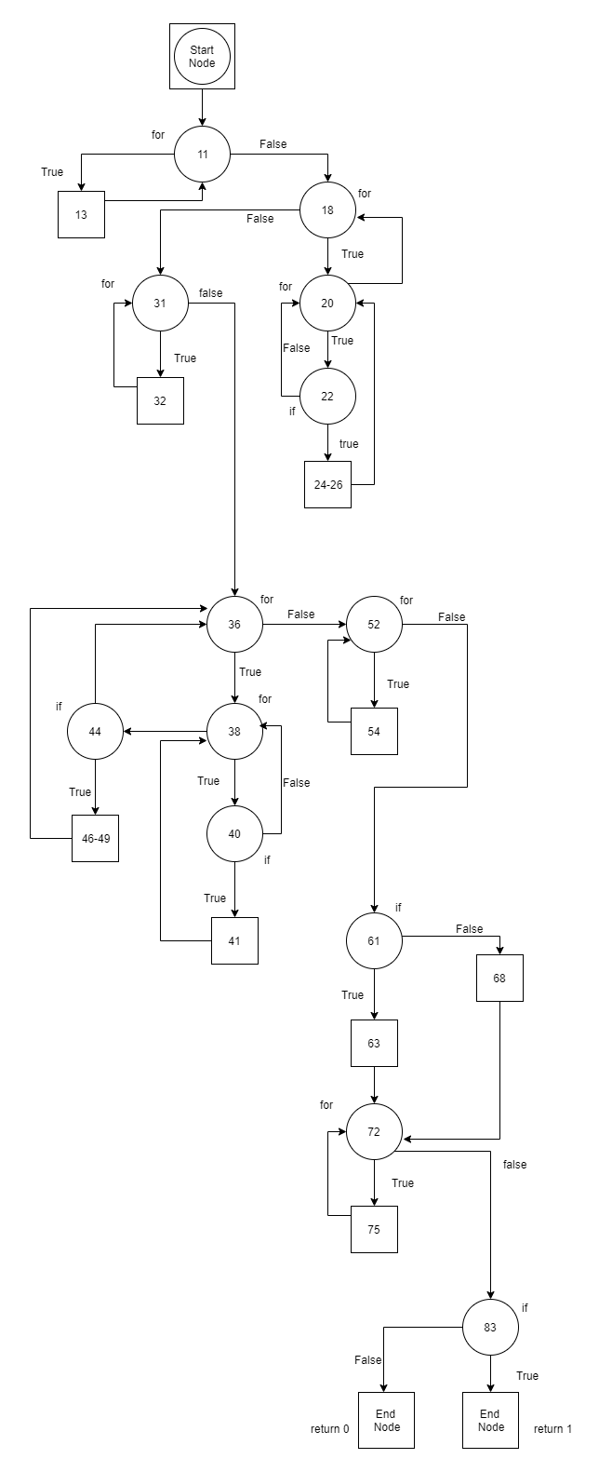

**Cyclomatic Complexity:**

**Number of Edges (e): 36**

**Number of Node (n): 25**

**Number of Separate Flow Graphs (C): 1**

Cyclomatic Complexity of Main Function = e-n+2C

= 36-25+2*1

= 11+2

= **13**